Installing SASS in Visual Studio Code
- Open VS Code
- Go to extensions tab

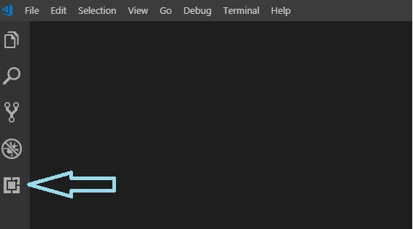
- Search for live sass compiler, the author is Ritwick Dey

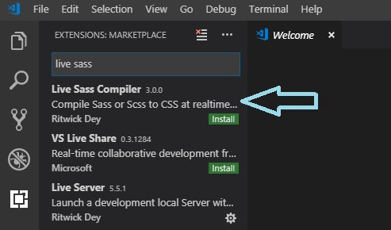
- Install it
- It will install live sass and live server which provides browser auto reloading
- Reload VS Code
- Create a folder named ‘test’ (or any ) for our project.
- Open that project directory using VS Code.
- Create an scss folder in our project root and inside create a filed named main.scss ,add some sass code inside.

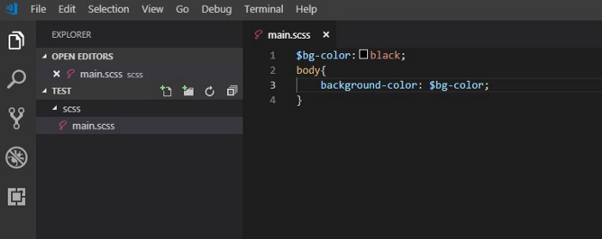
- Click watch sass at the bottom right corner
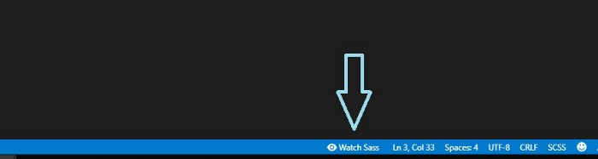
- Our main.scss file is compiled to main.css and we can see the compiled css here.

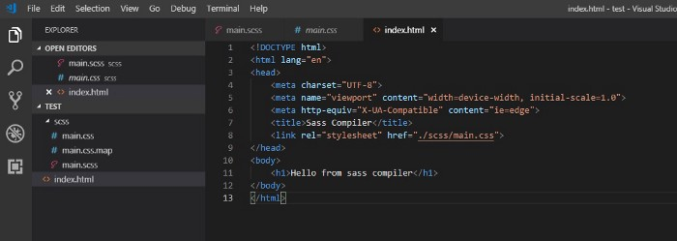
- I have added the font color as white in the main.scss.This is our output.



